10.40: The skater’s initial moment of inertia is

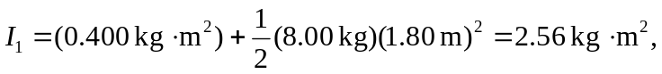
and her final moment of inertia is

Then from Eq. (10.33),

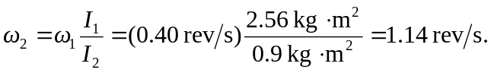

Note that conversion from rev/s to 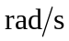 is not necessary.

